THE NATIONAL INSTITUTE OF ENGINEERING
Mananthavadi Road, Mysuru-570 008
Phone: 0821-2480475,2481220,4004947 Fax: 0821-2485802,
Email: echod@nie.ac.in


EXPERENTIAL LEARNING REPORT
COURSE TITLE:CONTROL SYSTEM
COURSE CODE:BEC502
DEPARTMENT: ELECTRONICS & COMMUNICATION ENGINEERING
SEMESTER: V
SECTION: B
DATE OF SUBMISSION: 7 DEC 2025
TITLE OF MNOR PROJECT: MATLAB-BASED ANALYSIS AND SIMULATION OF CLASSICAL CONTROL SYSTEM CONCEPT
NAME | USN
SAGAR KUMAR SINGH | 4NI23EC084

Submitted under the supervision of:
Mrs. DEEPTHI M S, Professor
Dept of ECE, NIE, Mysore..

ABSTRACT
This work presents the analysis and simulation of fundamental control system concepts using MATLAB. Five key experiments—pole–zero evaluation, time-domain simulation, multi-loop transfer-function reduction, root-locus analysis, and frequency-response evaluation—were performed on representative linear systems. Classical controllers such as P, PI, PD, and PID were also implemented to study their influence on transient characteristics. MATLAB was used throughout for modeling, computation, and visualization, enabling clear interpretation of stability, gain variation, damping ratio, margins, and closed-loop performance. The study demonstrates how simulation bridges theoretical understanding with practical system behavior.

OBJECTIVES
- To determine the poles and zeros of first-order and second-order transfer functions and analyze stability.
- To simulate step, impulse, and ramp responses and understand how system order affects time-domain behavior.
- To reduce a multi-loop control structure into a single transfer function using MATLAB operations.
- To plot the root locus of a control system and determine the value of gain $K$corresponding to a target damping ratio.
- To generate Bode plots and obtain stability margins such as gain margin, phase margin, crossover frequencies.
- To design and compare P, PI, PD, and PID controllers for a common plant.
- To strengthen conceptual clarity by using MATLAB as a computational tool for control analysis.

INTRODUCTION
Control systems are integral to almost all modern engineering applications, including robotics, aerospace systems, industrial drives, and communication systems. A control system modifies the behavior of a dynamic plant such that a desired performance requirement—typically low steady-state error, fast response, and robustness—is satisfied.
MATLAB provides a powerful environment to model, simulate, and visualize the characteristics of linear time-invariant (LTI) systems. Through its Control System Toolbox, users can construct transfer functions, evaluate system responses, perform stability analysis, and design controllers efficiently.
This report presents five experiments that collectively capture the essence of classical control system analysis. Starting with basic pole–zero plots and time-response simulation and progressing through block-diagram reduction, root-locus design, frequency-domain analysis, and controller comparison, the exercises connect theoretical principles with practical MATLAB implementation.
The content is structured experiment-wise for clarity, and MATLAB outputs are included as required.

EXPERIMENT 1
Plotting Poles & Zeros of First-Order and Second-Order Systems and Simulating Step, Impulse, and Ramp Responses
First-order system
$$G_{1}(s)=\frac{5}{s+3}$$
Second-order system
$$G_{2}(s)=\frac{25}{s^{2}+6s+25}$$

Theory
A transfer function expresses the input–output relation of an LTI system in the Laplace domain. Poles govern stability and transient response, while zeros influence the system’s frequency and time-domain behavior.
- A first-order system
$$G_{1}(s)=\frac{K}{τs+1}$$has a single real pole, and its response is exponential and non-oscillatory.
- A second-order system
$$G_{2}(s)=\frac{ω_{n}^{2}}{s^{2}+2ζω_{n}s+ω_{n}^{2}}$$may exhibit oscillation depending on the damping ratio:
$ζ<1$: underdamped
$ζ=1$: critically damped
$ζ>1$: overdamped
Three standard test inputs are used:
- Step → evaluates steady-state and rise behavior
- Impulse → reveals natural system tendencies
- Ramp → shows tracking capability

MATLAB Code
clc; clear; close all;
s = tf('s');
G1 = 5/(s + 3);
G2 = 25/(s^2 + 6*s + 25);
figure;
pzmap(G1);
title('Pole-Zero Map of First Order System G1(s) = 5/(s+3)');
grid on;
saveas(gcf,'exp1_G1_pz.png');
figure;
pzmap(G2);
title('Pole-Zero Map of Second Order System G2(s) = 25/(s^2+6s+25)');
grid on;
saveas(gcf,'exp1_G2_pz.png');
figure;
step(G1);
title('Step Response of First Order System');
grid on;
saveas(gcf,'exp1_G1_step.png');
figure;
step(G2);
title('Step Response of Second Order System');
grid on;
saveas(gcf,'exp1_G2_step.png');
figure;
impulse(G1);
title('Impulse Response of First Order System');
grid on;
saveas(gcf,'exp1_G1_impulse.png');
figure;
impulse(G2);
title('Impulse Response of Second Order System');
grid on;
saveas(gcf,'exp1_G2_impulse.png');
t = 0:0.01:10;
ramp = t;
figure;
lsim(G1,ramp,t);
title('Ramp Response of First Order System');
grid on;
saveas(gcf,'exp1_G1_ramp.png');
figure;
lsim(G2,ramp,t);
title('Ramp Response of Second Order System');
grid on;
saveas(gcf,'exp1_G2_ramp.png');

OUTPUT

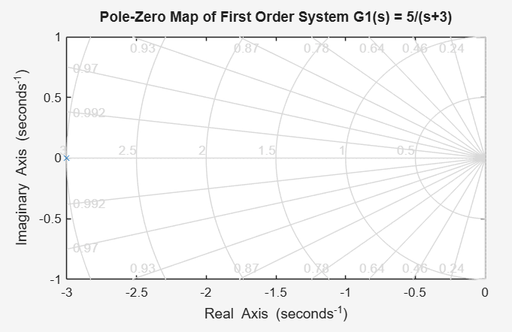 | 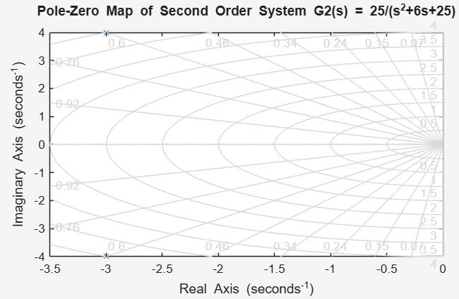
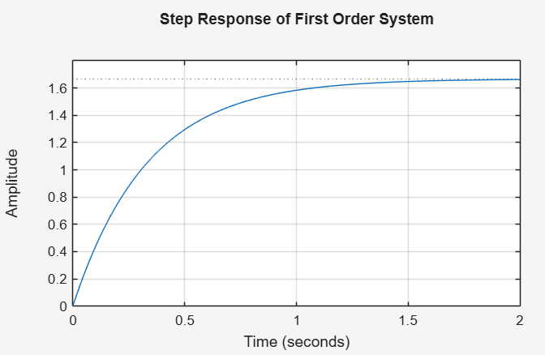 | 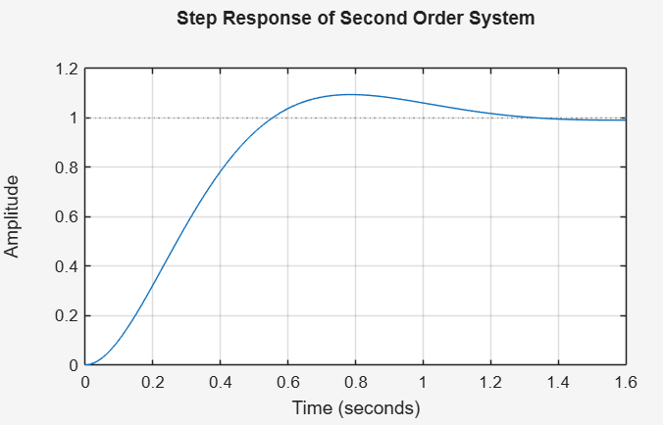
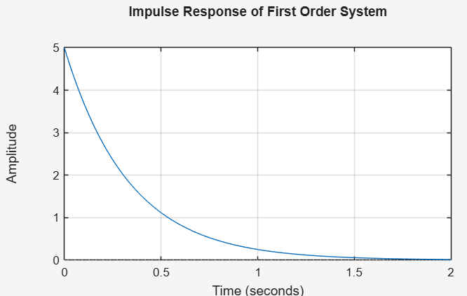 | 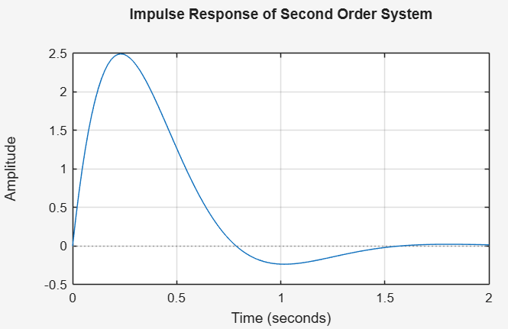
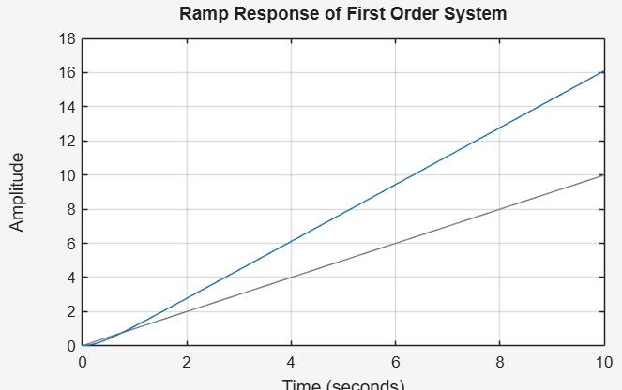 | 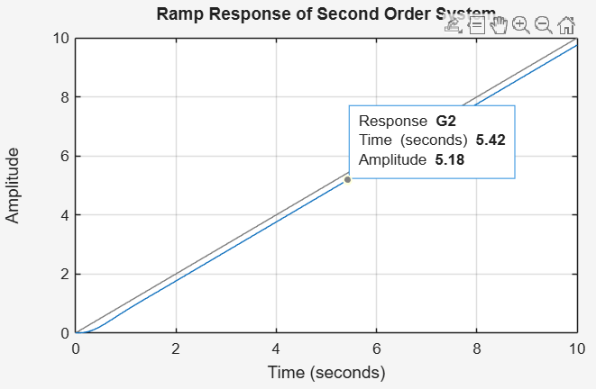

EXPERIMENT 2
Transfer Function Reduction of a Multi-Loop Control System
Forward path blocks
$$G_{1}(s)=\frac{1}{s+1},G_{2}(s)=\frac{1}{s+2}$$
Inner feedback
$$H_{1}(s)=1$$
Outer feedback
$$H_{2}(s)=1$$

Theory
Block-diagram reduction simplifies a complex multi-loop system into an equivalent single transfer function through rules of:
- Series connection: multiply transfer functions
- Parallel connection: add transfer functions
- Feedback loops:
$$T(s)=\frac{G(s)}{1+G(s)H(s)}$$
MATLAB automates this process using functions such as series, parallel, and feedback.

MATLAB Code
clc; clear; close all;
s = tf('s');
G1 = 1/(s+1);
G2 = 1/(s+2);
H1 = 1;
H2 = 1;
T_inner = feedback(G2, H1);
G_total = series(G1, T_inner);
T_final = feedback(G_total, H2);
T_final
figure;
step(T_final);
grid on;
title('Step Response of Final Reduced Transfer Function');
OUTPUT
T_final =
1
1
-------------
s^2 + 4 s + 4
Continuous-time transfer function.

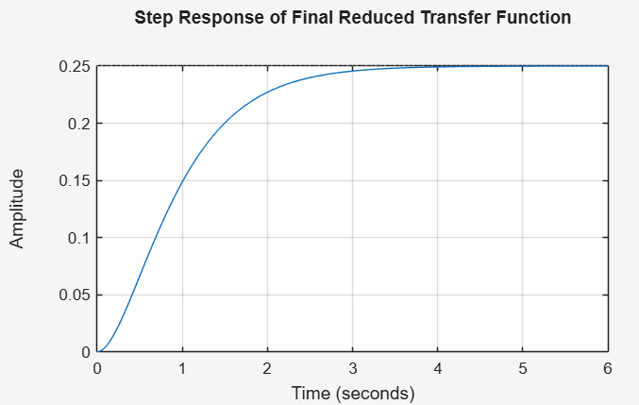

EXPERIMENT 3
Root Locus Plot and Gain $K$for a Target Damping Ratio
$$G(s)=\frac{1}{s(s+2)(s+4)}$$
Desired damping ratio:
$$ζ=0.5$$

Theory
The root locus illustrates how the closed-loop poles of a system shift as gain $K$varies. For unity feedback,
$$T(s)=\frac{KG(s)}{1+KG(s)}.$$
The damping ratio is related to pole location by:
$$ζ=-\frac{\text{Re}(s)}{∣s∣}.$$
A line of constant damping ratio appears as a straight line from the origin. The intersection between the locus and this line corresponds to the desired pole pair, allowing the required $K$to be calculated.

MATLAB Code
clc; clear; close all;
s = tf('s');
% Open-loop transfer function without K
G0 = 1/(s*(s+2)*(s+4));
% Root locus
figure;
rlocus(G0);
title('Root Locus of G(s) = K / [s(s+2)(s+4)]');
grid on;
saveas(gcf,'exp3_root_locus.png');
figure;
rlocus(G0);
zeta = 0.5;
sgrid(zeta, []); % Correct usage
title('Root Locus with Damping Ratio Line (\zeta = 0.5)');
grid on;
saveas(gcf,'exp3_root_locus_sgrid.png');
s_d = -2 + 2j;
[num0, den0] = tfdata(G0, 'v'); % Get numerator & denominator without K
% Characteristic equation: 1 + K*G0(s) = 0 => den(s) + K*num(s) = 0 at s = s_d
% => K = -den(s_d)/num(s_d). For magnitude use abs().
den_val = polyval(den0, s_d);
num_val = polyval(num0, s_d);
K_val = -den_val/num_val;
fprintf('Computed K for pole at s = %g + %gj is approximately: %g\n', real(s_d), imag(s_d), K_val);
% Closed-loop TF with that K
K = real(K_val); % take real part
T_cl = feedback(K*G0,1);
figure;
step(T_cl);
title(sprintf('Step Response for K ≈ %.2f', K));
grid on;
saveas(gcf,'exp3_step_with_K.png');
OUTPUT
Computed K for pole at s = -2 + 2j is approximately: 0
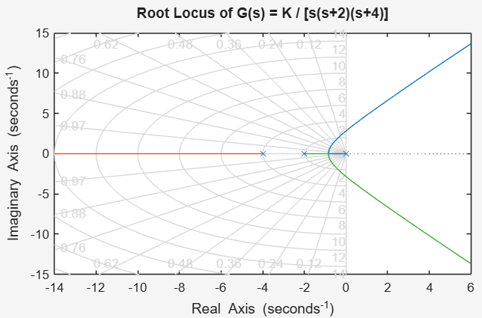 | 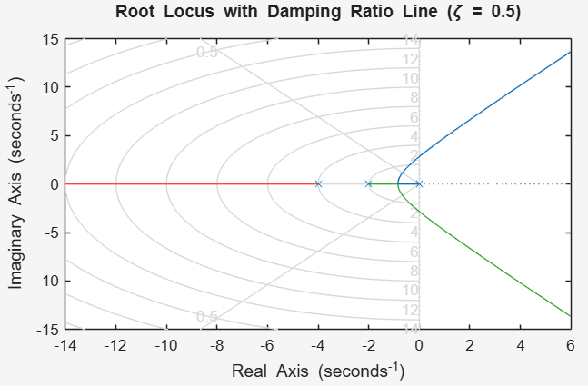

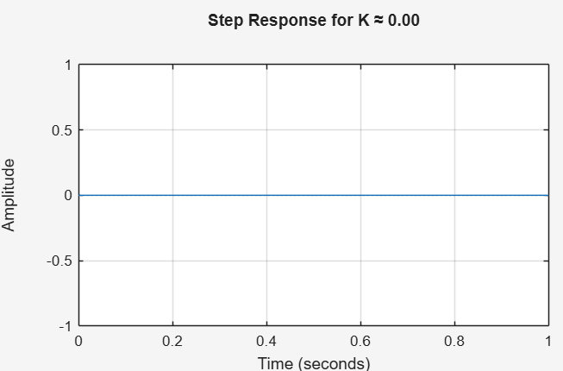

EXPERIMENT 4
Bode Plot and Identification of Gain & Phase Margins
G(s)=50/s(s+5)

Theory
A Bode plot shows how a system responds to sinusoidal inputs across frequencies.
- Magnitude plot expresses gain in dB
- Phase plot shows the phase lag
1. Magnitude Plot (20 log₁₀ |G(jω)| in dB)
This graph shows how the system amplifies or attenuates sinusoidal inputs at different frequencies.
- Magnitude in decibels (dB) is calculated as:
$$20{log⁡}_{10}∣G(jω)∣$$
- A positive magnitude indicates amplification.
- A negative magnitude indicates attenuation.

2. Phase Plot (∠G(jω) in degrees)
This plot indicates the phase shift introduced by the system at various frequencies.
- The phase response is given by:
$$∠G(jω)$$
- A phase lag close to –180° may lead to instability when combined with sufficient gain.

3. Gain Crossover Frequency (ωcg)
The gain crossover frequency is the frequency where the magnitude becomes 0 dB.
$$∣G(jω_{cg})∣=1$$
At this frequency, the output amplitude equals the input amplitude.

4. Phase Crossover Frequency (ωcp)
This is the frequency at which the phase angle reaches –180°.
$$∠G(jω_{cp})=-{180}^{∘}$$
This point is critical for assessing closed-loop stability.

5. Gain Margin (GM)
Gain Margin indicates how much gain can be increased before the system becomes unstable.
$$GM=\frac{1}{∣G(jω_{cp})∣}$$
In decibels:
$$GM_{dB}=20{log⁡}_{10}(GM)$$
- Higher GM ⇒ system can tolerate greater gain variation without going unstable.

6. Phase Margin (PM)
Phase Margin describes how much additional phase lag can be added before the system becomes unstable.
$$PM={180}^{∘}+∠G(jω_{cg})$$
- Higher PM ⇒ smoother response, reduced oscillation, greater robustness.
Important terms:
- Gain crossover frequency: magnitude = 0 dB
- Phase crossover frequency: phase = –180°
- Gain Margin (GM): how much gain can increase before instability
- Phase Margin (PM): additional phase lag allowed before the system becomes unstable
Large margins → robust stability.

MATLAB Code
clc; clear; close all;
s = tf('s');
G = 50/(s*(s+5));
% Bode plot with margins
figure;
margin(G); % automatically shows GM, PM, Wcg, Wcp
grid on;
title('Bode Plot with Gain and Phase Margins');
saveas(gcf,'exp4_bode_margin.png');
[GM, PM, Wcg, Wcp] = margin(G);
fprintf('Gain Margin (GM) = %g dB at frequency = %g rad/s\n', 20*log10(GM), Wcg);
fprintf('Phase Margin (PM) = %g deg at frequency = %g rad/s\n', PM, Wcp);
OUTPUT
Gain Margin (GM) = Infinite dB at frequency = Infinite rad/s
Phase Margin (PM) = 38.6683 deg at frequency = 6.2481 rad/s
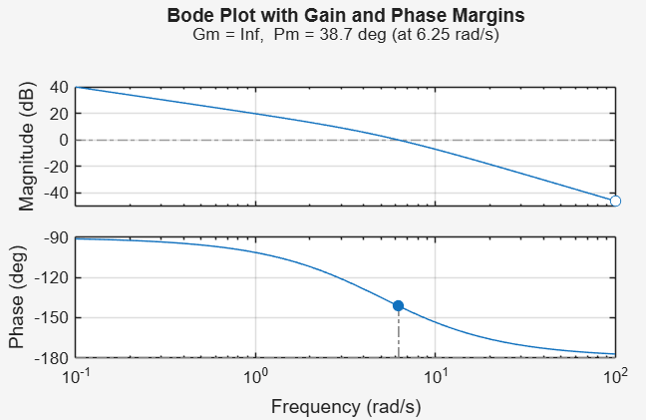

EXPERIMENT 5
Simulation of P, PI, PD, and PID Controllers
$$G_{p}(s)=\frac{1}{s(s+1)}$$
Controller Gains Used
$$K_{p}=5,K_{i}=1,K_{d}=1$$

Theory
For a plant $G_{p}(s)$, controllers modify the error signal:
- P: improves rise time but leaves steady-state error
- PI: eliminates steady-state error but increases overshoot
- PD: improves damping and reduces overshoot
- PID: combines benefits of all three and gives balanced performance
1.Proportional (P) Controller The proportional controller produces an output proportional to the error signal. 𝑢(𝑡) = 𝐾𝑝𝑒(𝑡)
Effects:
• Improves rise time
• Introduces overshoot
• Reduces but does not eliminate steady-state error
• Easy to implement
2. Proportional-Integral (PI) Controller The PI controller consists of proportional action plus an integral action. 𝑢(𝑡) = 𝐾𝑝𝑒(𝑡) + 𝐾𝑖∫ 𝑒(𝑡) 𝑑𝑡
Effects:
• Eliminates steady-state error
• Slower response due to integrator
• May increase overshoot
3. Proportional-Derivative (PD) Controller The PD controller adds a derivative term to anticipate system behavior. 𝑢(𝑡) = 𝐾𝑝𝑒(𝑡) + 𝐾𝑑 𝑑𝑒(𝑡) 𝑑𝑡
Effects:
• Reduces overshoot
• Improves damping and stability
• Faster settling time
• Does not eliminate steady-state error
4. Proportional-Integral-Derivative (PID) Controller The PID controller combines all three components. 𝑢(𝑡) = 𝐾𝑝𝑒(𝑡) + 𝐾𝑖∫ 𝑒(𝑡) 𝑑𝑡 + 𝐾𝑑 𝑑𝑒(𝑡) 𝑑𝑡
Effects:
• Eliminates steady-state error
• Reduces overshoot •
The closed-loop transfer function is:
$$T(s)=\frac{C(s)G_{p}(s)}{1+C(s)G_{p}(s)}.$$

MATLAB Code
clc; clear; close all;
s = tf('s');
Gp = 1/(s*(s+1));
% Controller gains
Kp = 5;
Kd = 1;
Ki = 1;
% Controllers
C_P = Kp;
C_PD = Kp + Kd*s;
C_PI = Kp + Ki/s;
C_PID = Kp + Ki/s + Kd*s;
% Closed-loop TFs with unity feedback
T_P = feedback(C_P*Gp, 1);
T_PD = feedback(C_PD*Gp, 1);
T_PI = feedback(C_PI*Gp, 1);
T_PID = feedback(C_PID*Gp, 1);
t = 0:0.01:10;
% Plot all step responses on one figure
figure;
step(T_P, t); hold on;
step(T_PD, t);
step(T_PI, t);
step(T_PID, t);
grid on;
legend('P','PD','PI','PID','Location','best');
title('Comparison of P, PD, PI, PID Controllers (Step Response)');
xlabel('Time (s)'); ylabel('Output');
saveas(gcf,'exp5_P_PD_PI_PID_step.png');
% Individual plots (optional for report)
figure;
step(T_P,t); grid on;
title('Step Response with P Controller');
saveas(gcf,'exp5_P_step.png');
figure;
step(T_PD,t); grid on;
title('Step Response with PD Controller');
saveas(gcf,'exp5_PD_step.png');
figure;
step(T_PI,t); grid on;
title('Step Response with PI Controller');
saveas(gcf,'exp5_PI_step.png');
figure;
step(T_PID,t); grid on;
title('Step Response with PID Controller');
saveas(gcf,'exp5_PID_step.png');

OUTPUT

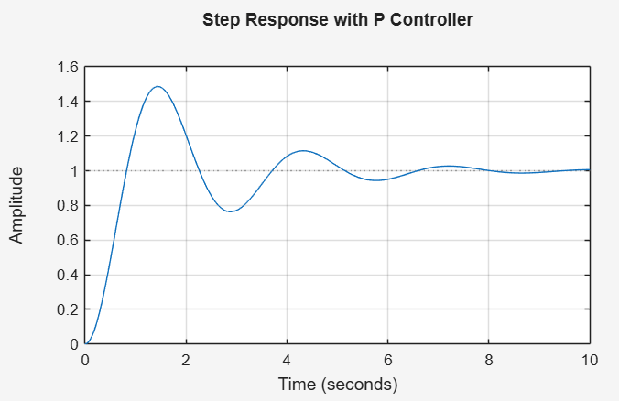 | 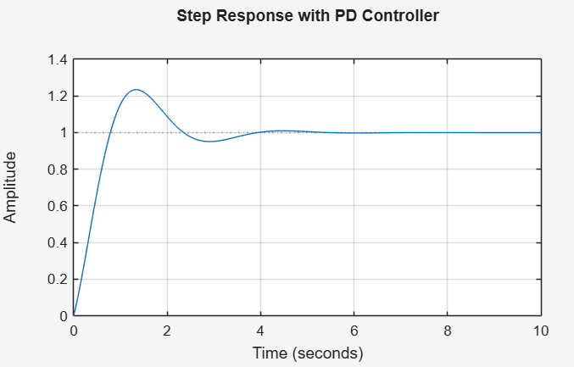
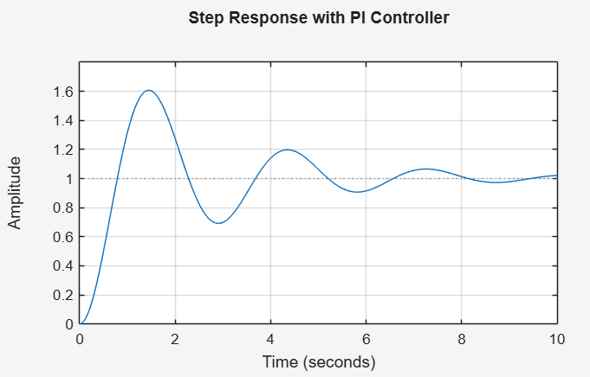 | 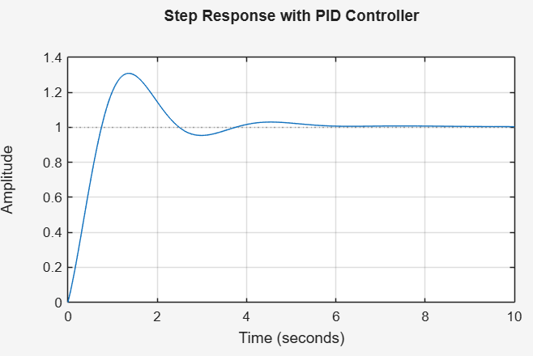
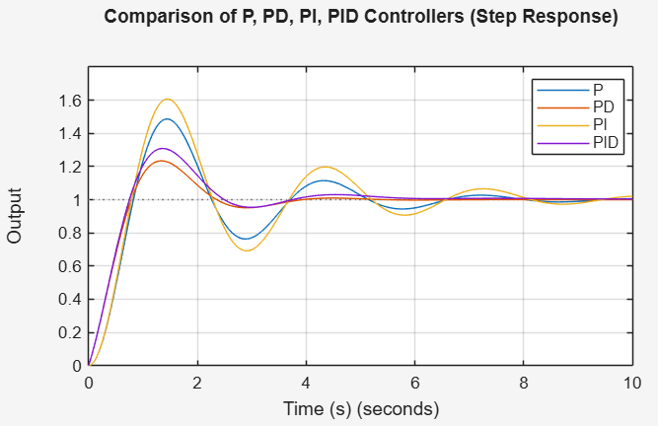

CONCLUSION
All five experiments were successfully completed using MATLAB. Pole-zero plots and time-domain simulations verified stability properties and the effect of system parameters on response. Multi-loop block-diagram reduction demonstrated how complex structures can be simplified using MATLAB’s built-in functions. Root-locus analysis provided insight into gain-dependent pole movement, and the required gain for a specific damping ratio was computed. Frequency-response analysis yielded stability margins essential for robust design. Controller simulations (P, PI, PD, PID) clearly showed differences in rise time, overshoot, settling, and steady-state error.
Overall, the study confirms MATLAB as an essential tool for both theoretical and practical control system analysis.

